Project details

Sauce demo application -> shopping website

Action to be performed is as below

1. Login to website
2. Add the items to cart
3. Check out the items and finish the shopping
4. Verify the thanks you message

**Test cases designed**



**Risk Mitigation Plan**



Tools used

Java, Maven, cucumber, Junit, TestNG annotations, Extend reports, POM

Project folder structure

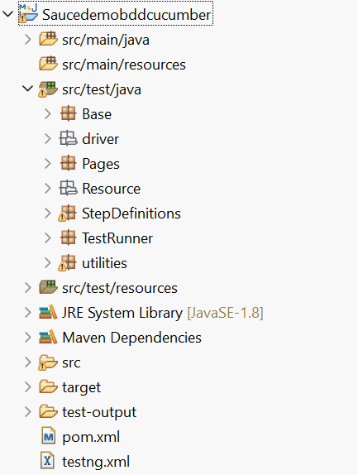

All the dependency are added in the POM. XML file

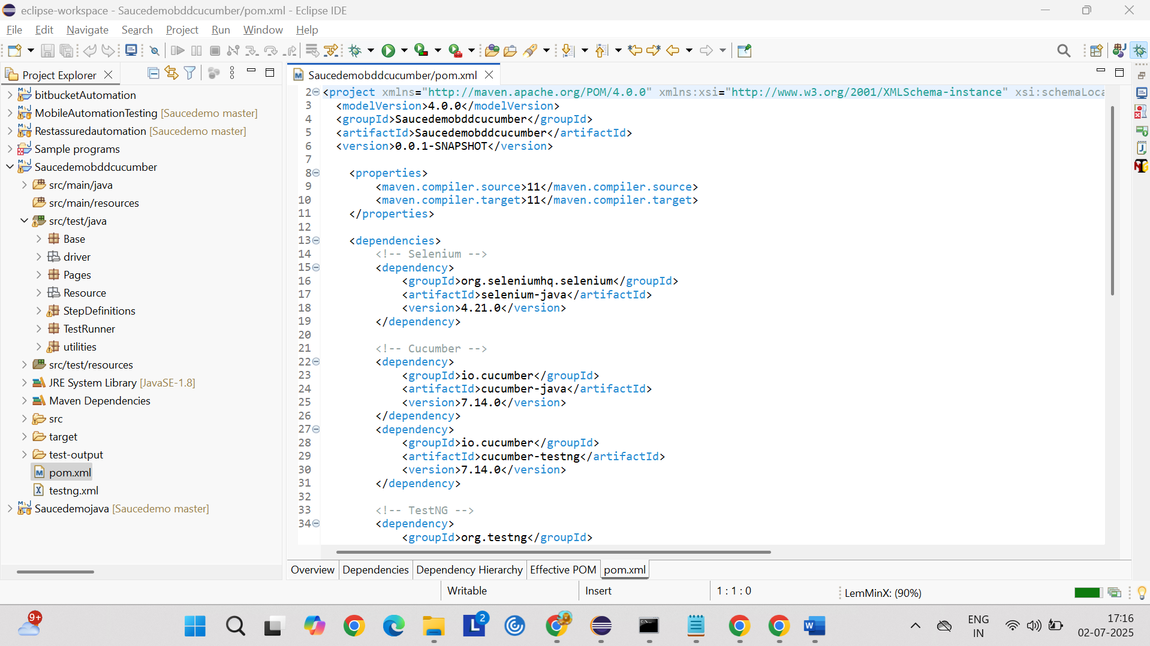

Packages

1. Base
2. Pages
3. Step Definitions
4. TestRunner
5. Utilities
6. drivers

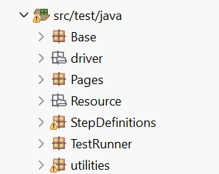

Feature file

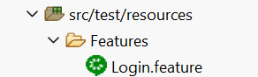

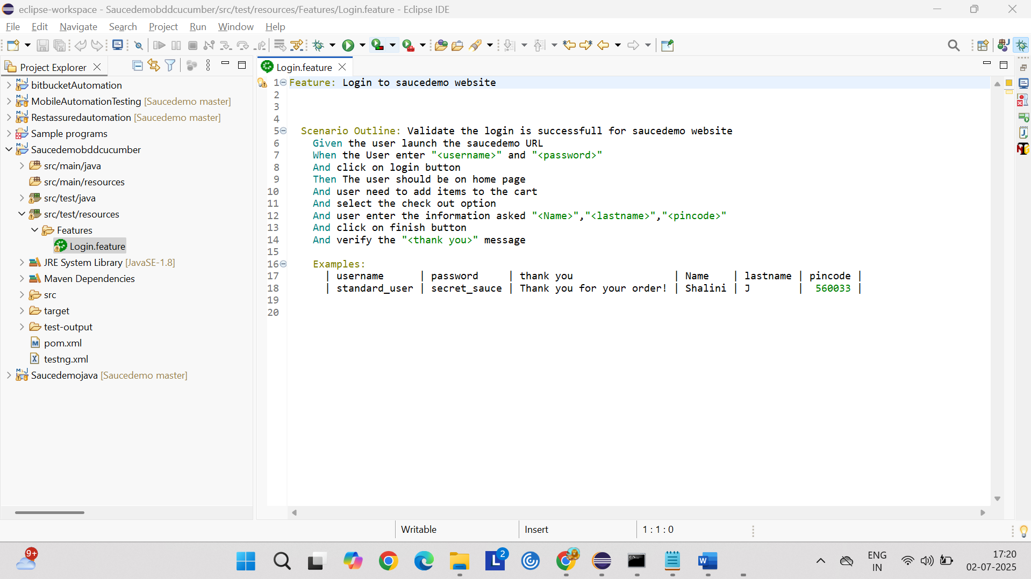

Step Definition implemented for above feature file

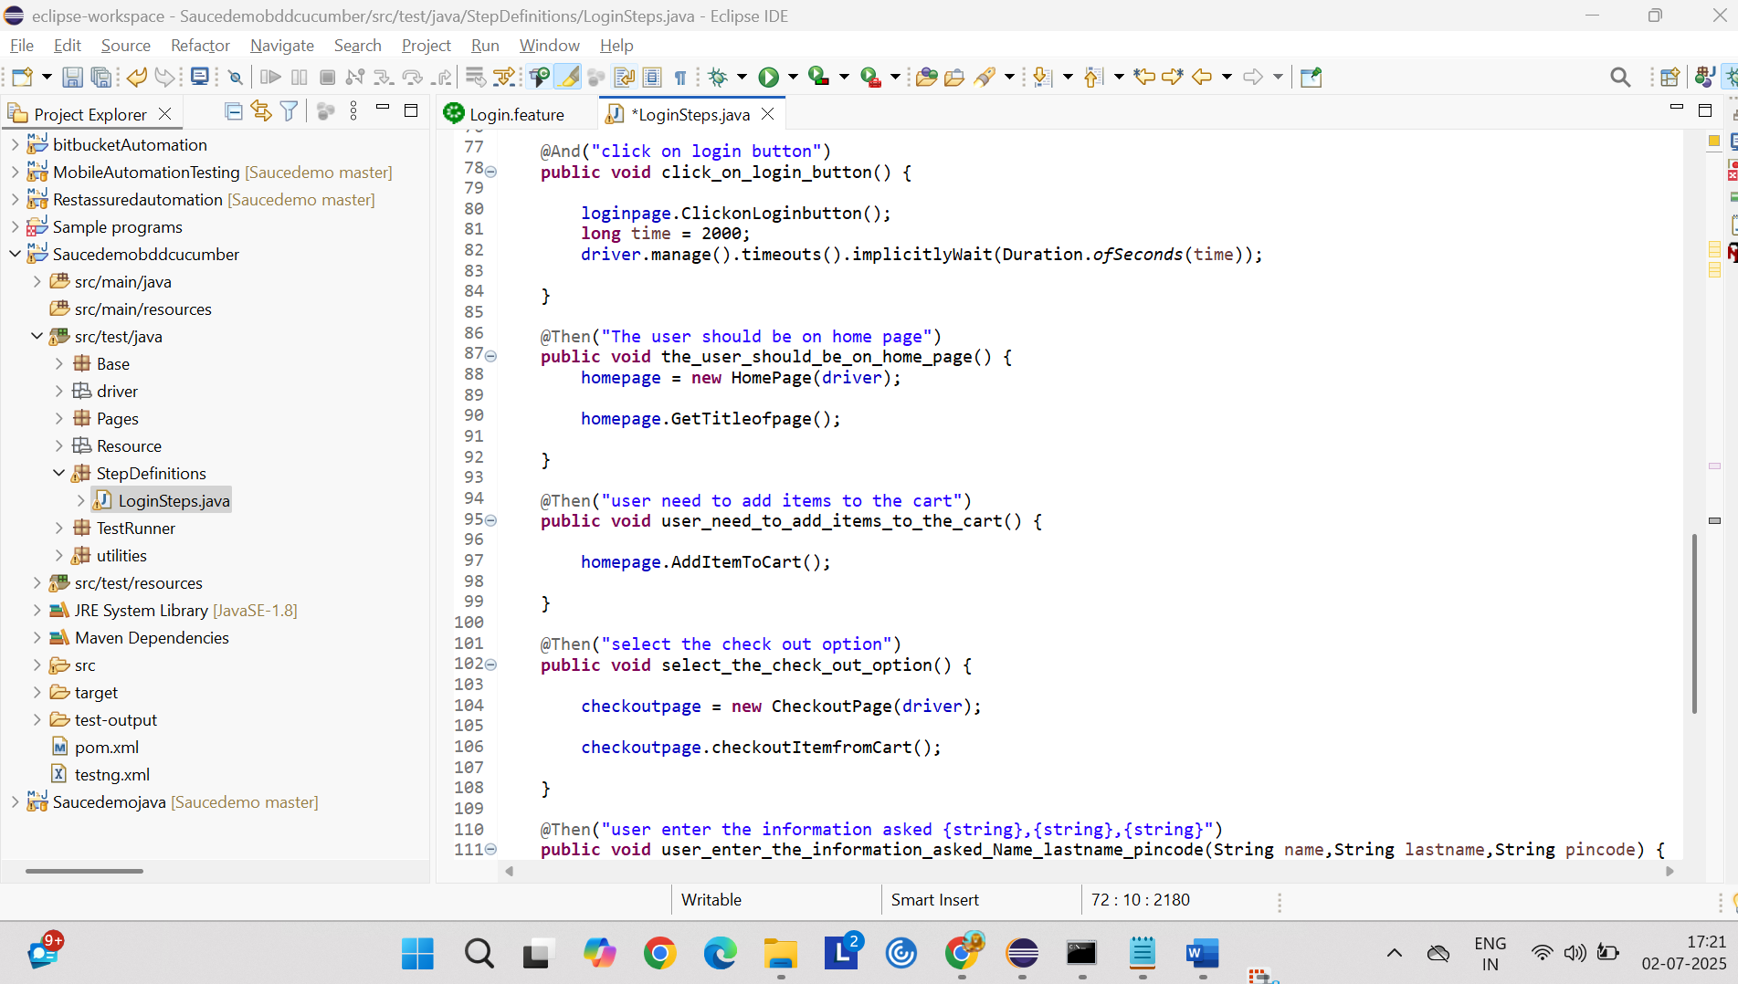

Page package has below page classes for each web page in the application

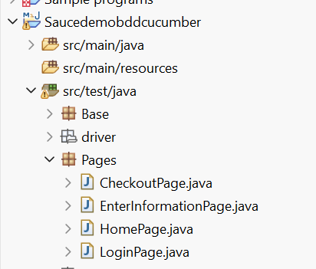

Login page with methods and login page locators

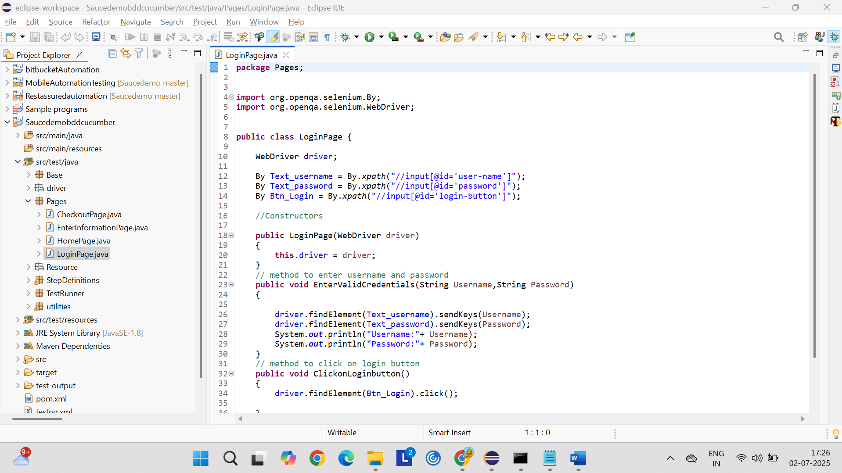

Home Page

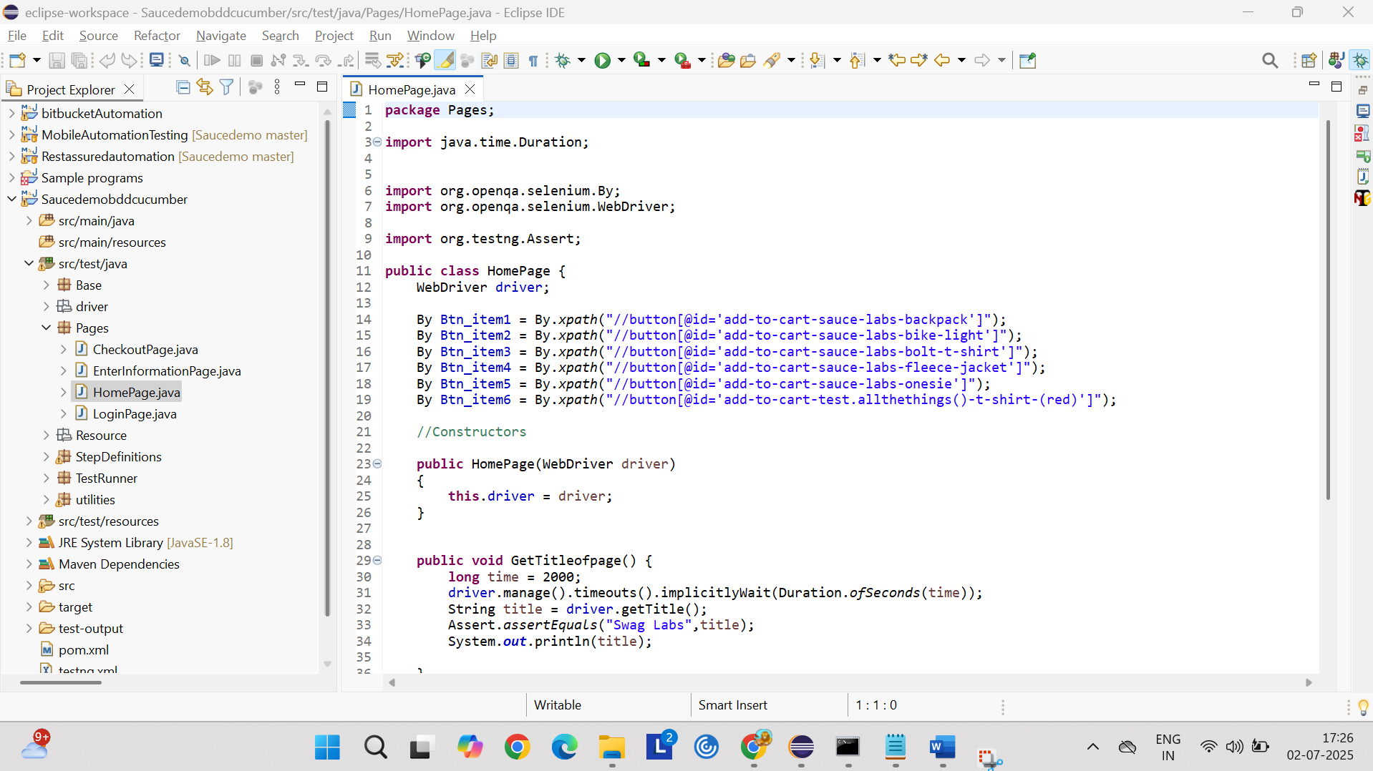

Check out page

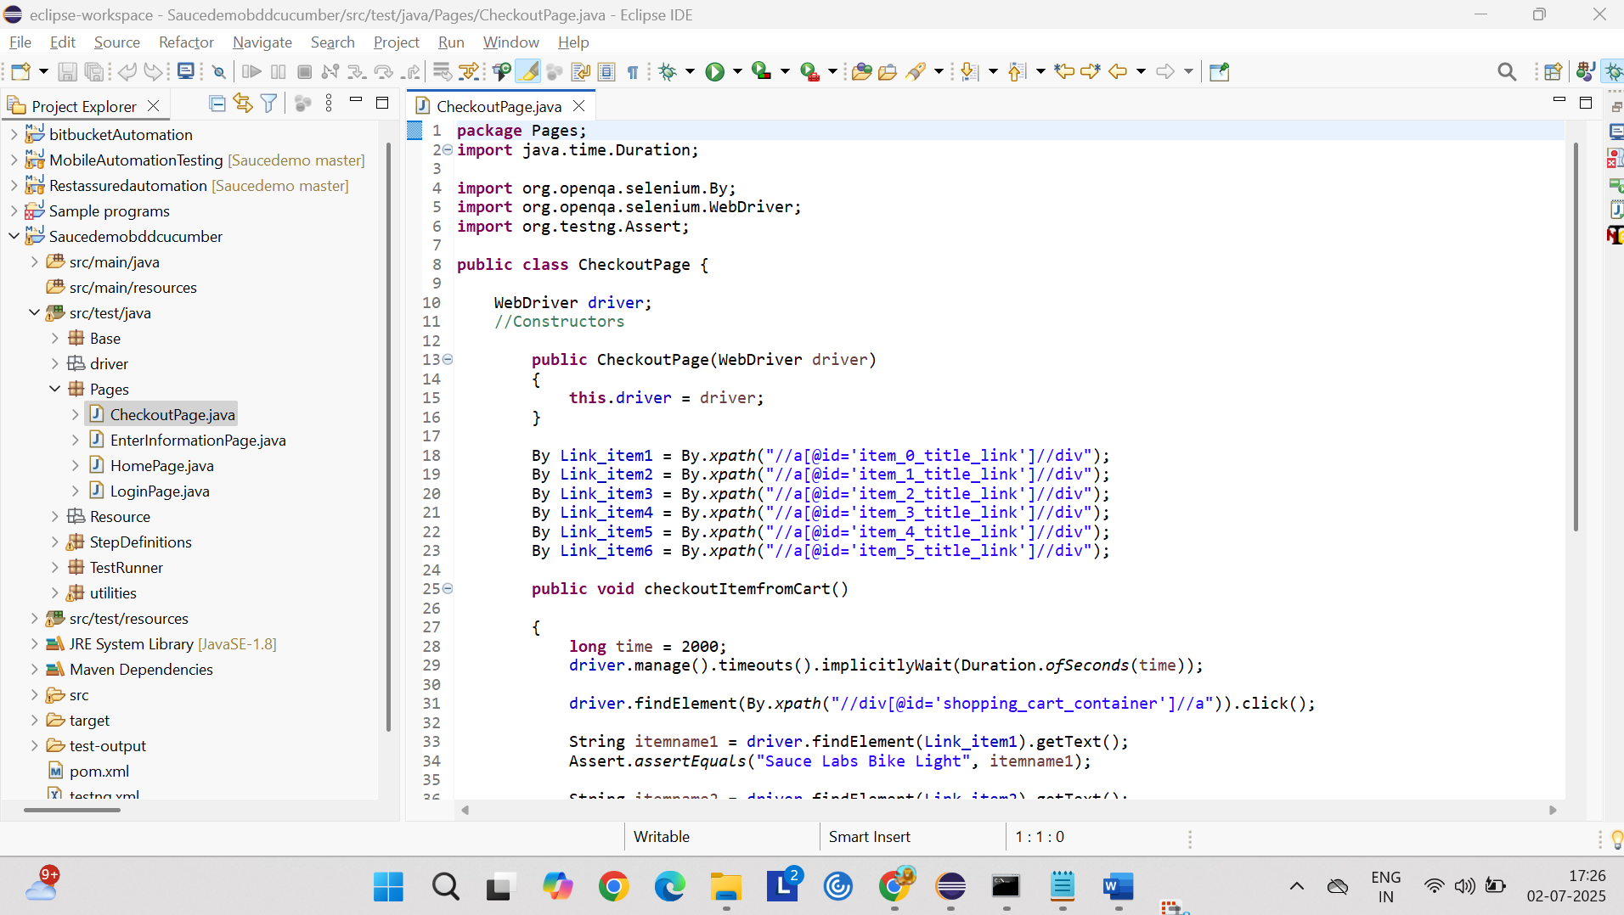

Enter information page

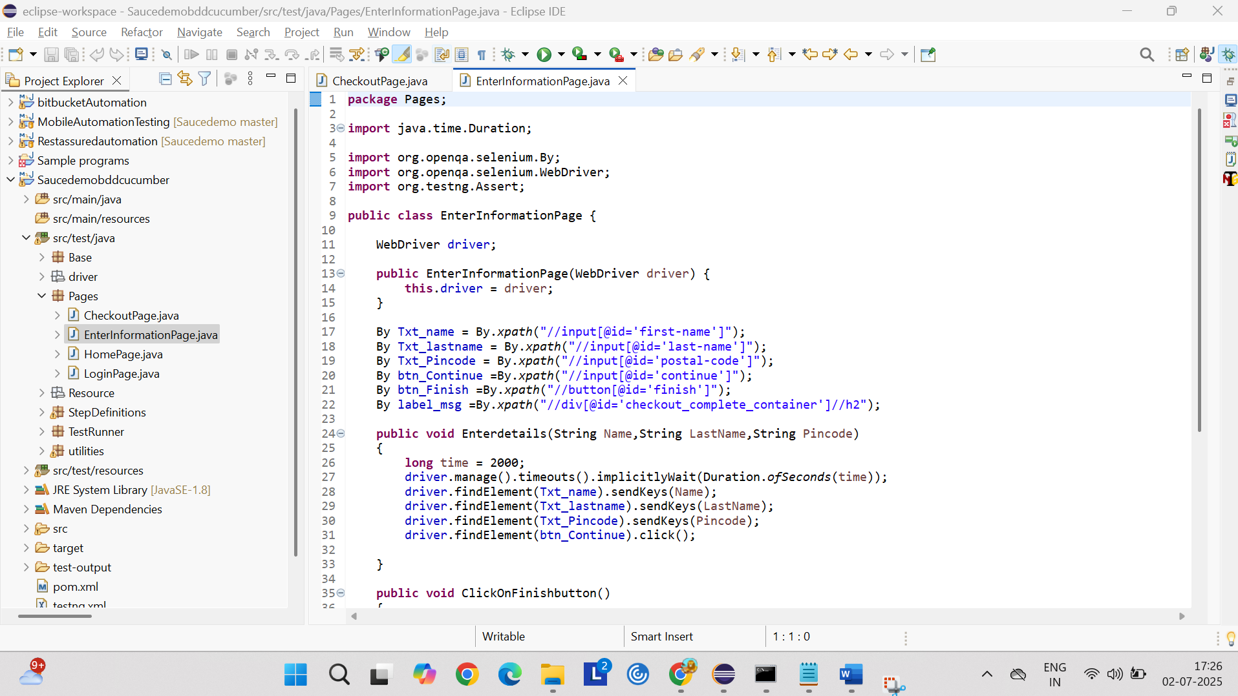

Test runner class with Junit

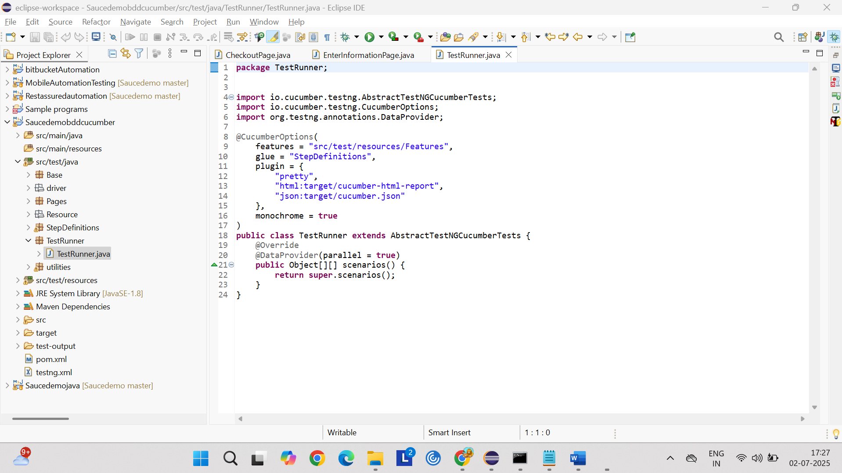

Utilities package has below class

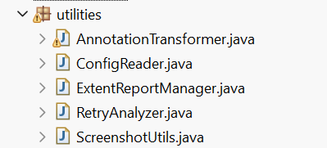

AnnotationTransformer

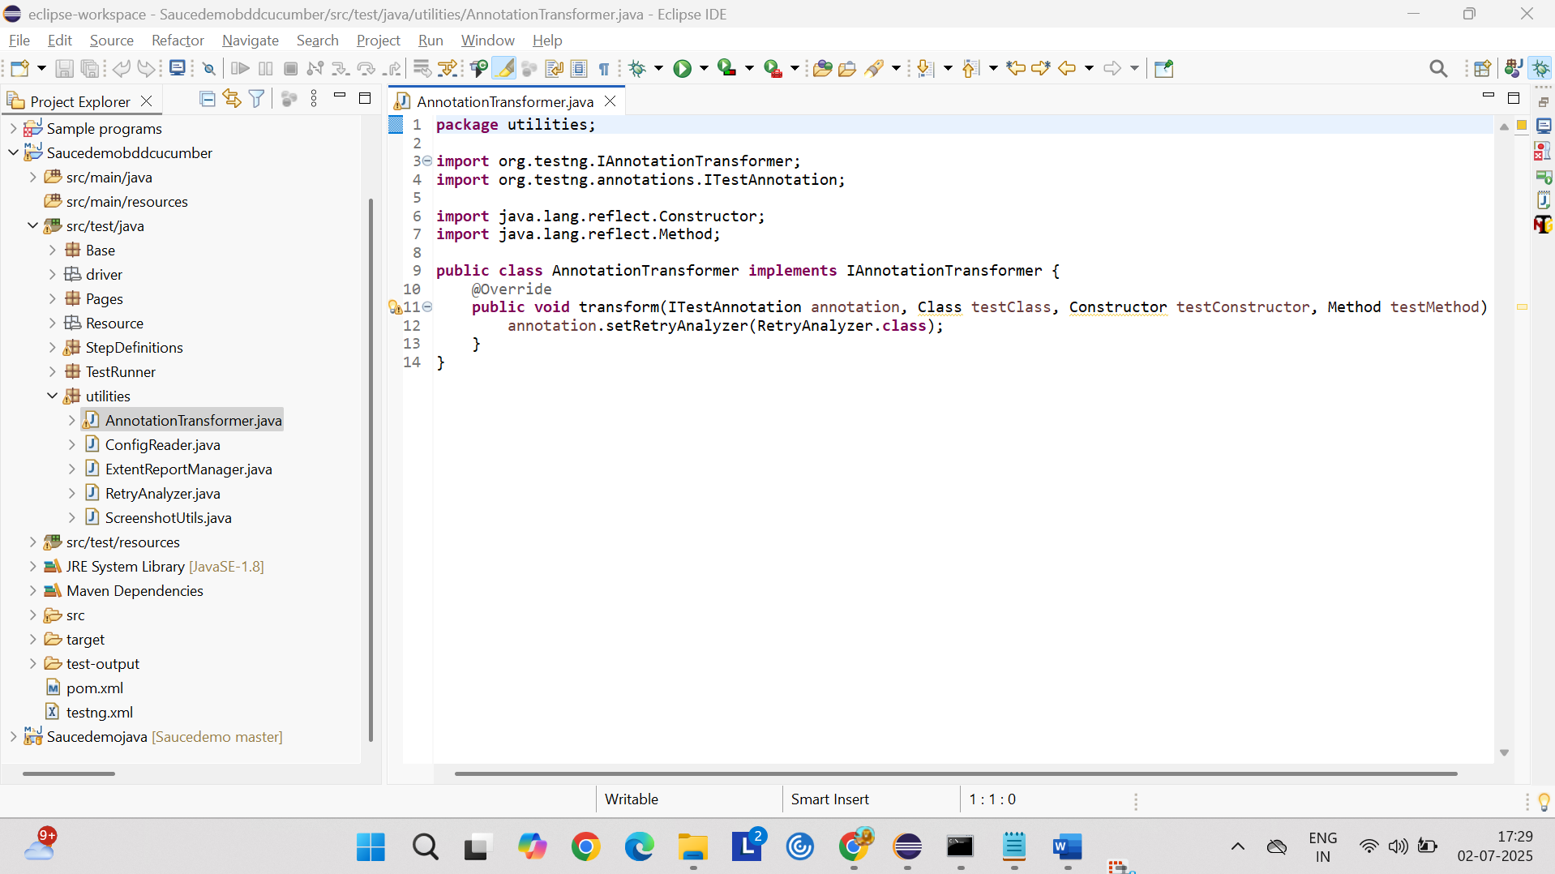

ExtentReportManager

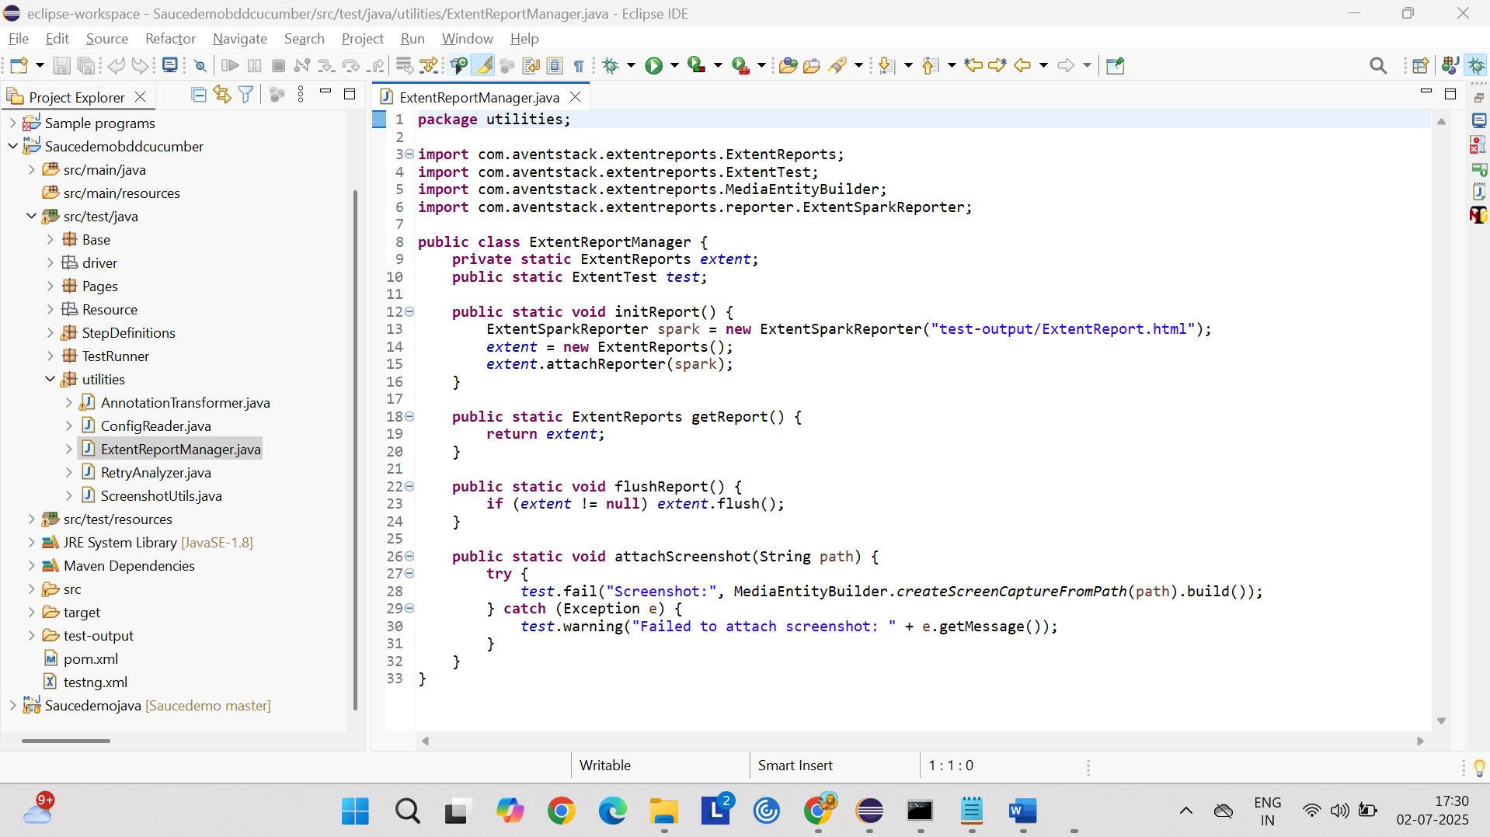

RetryAnalyzer

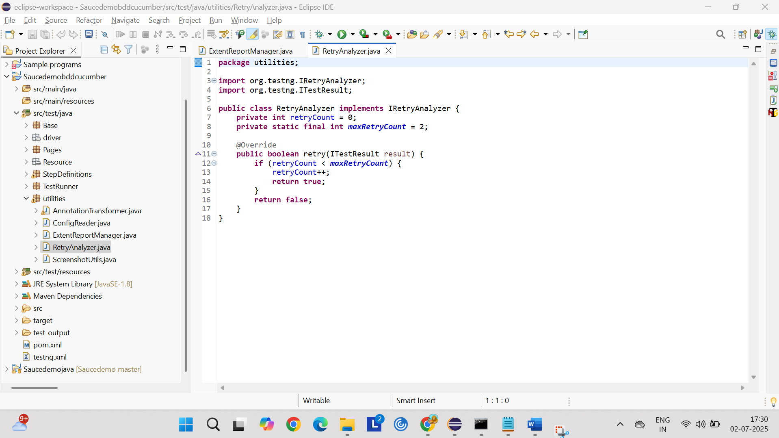

Screenshoututils

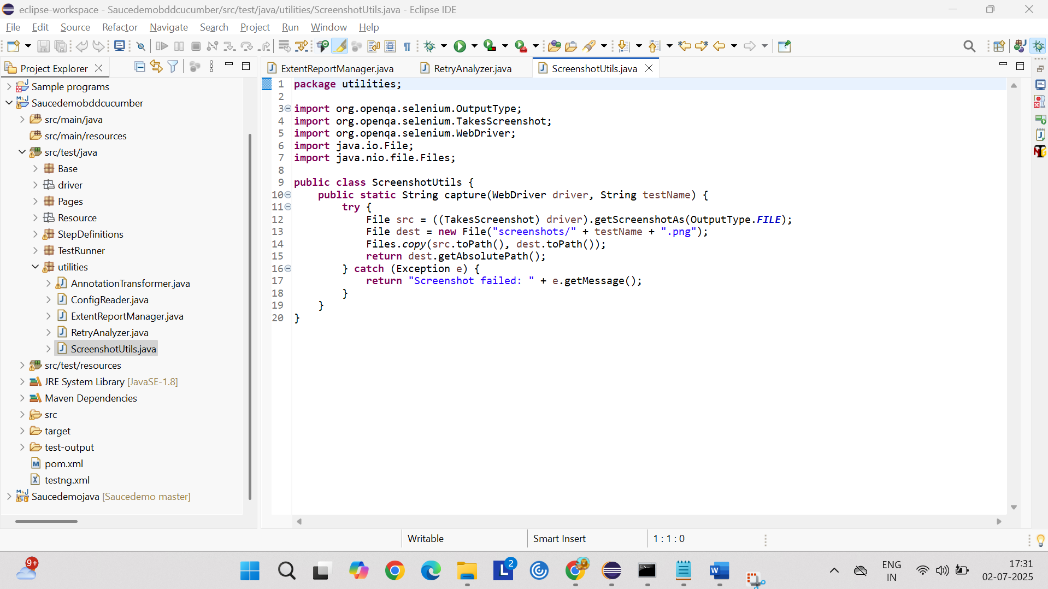

TestNG.xml

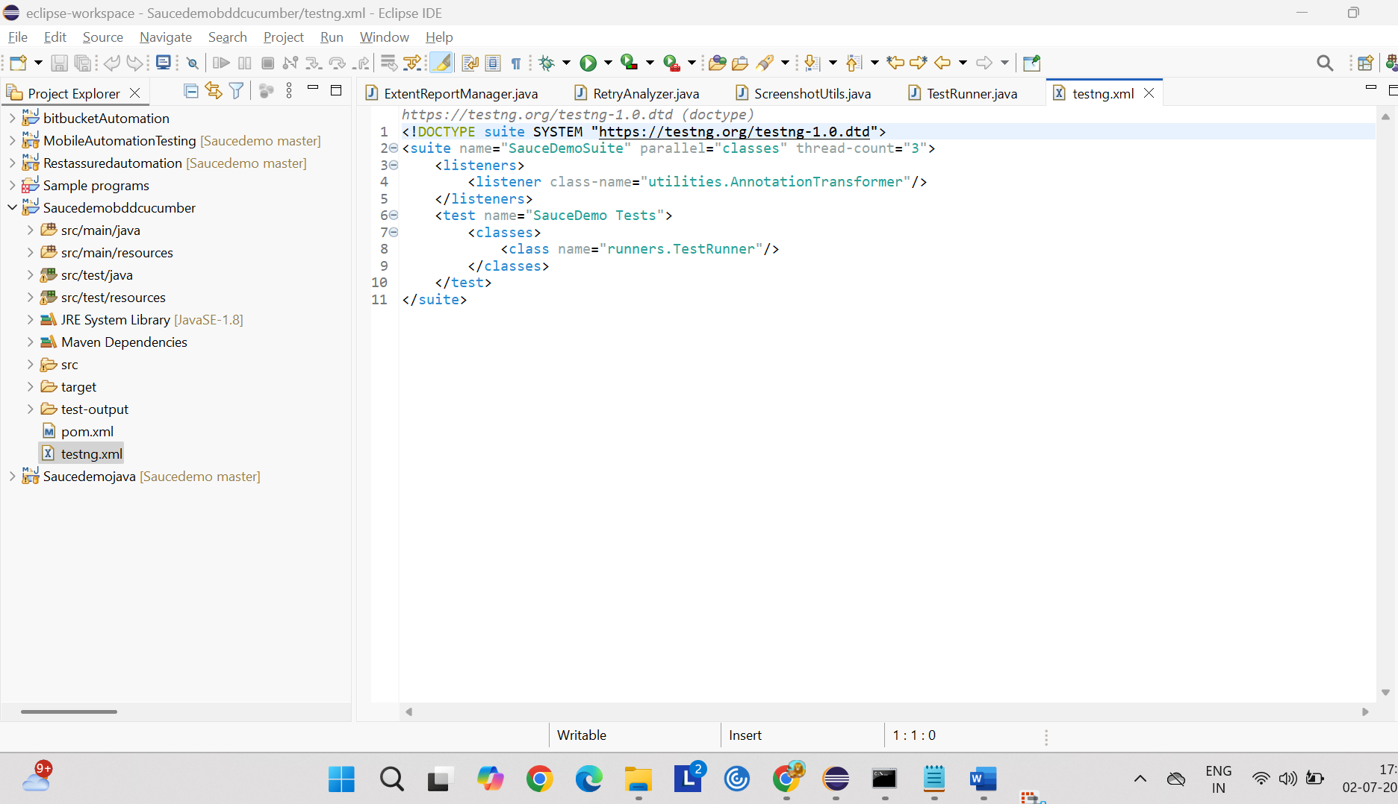

Recording

